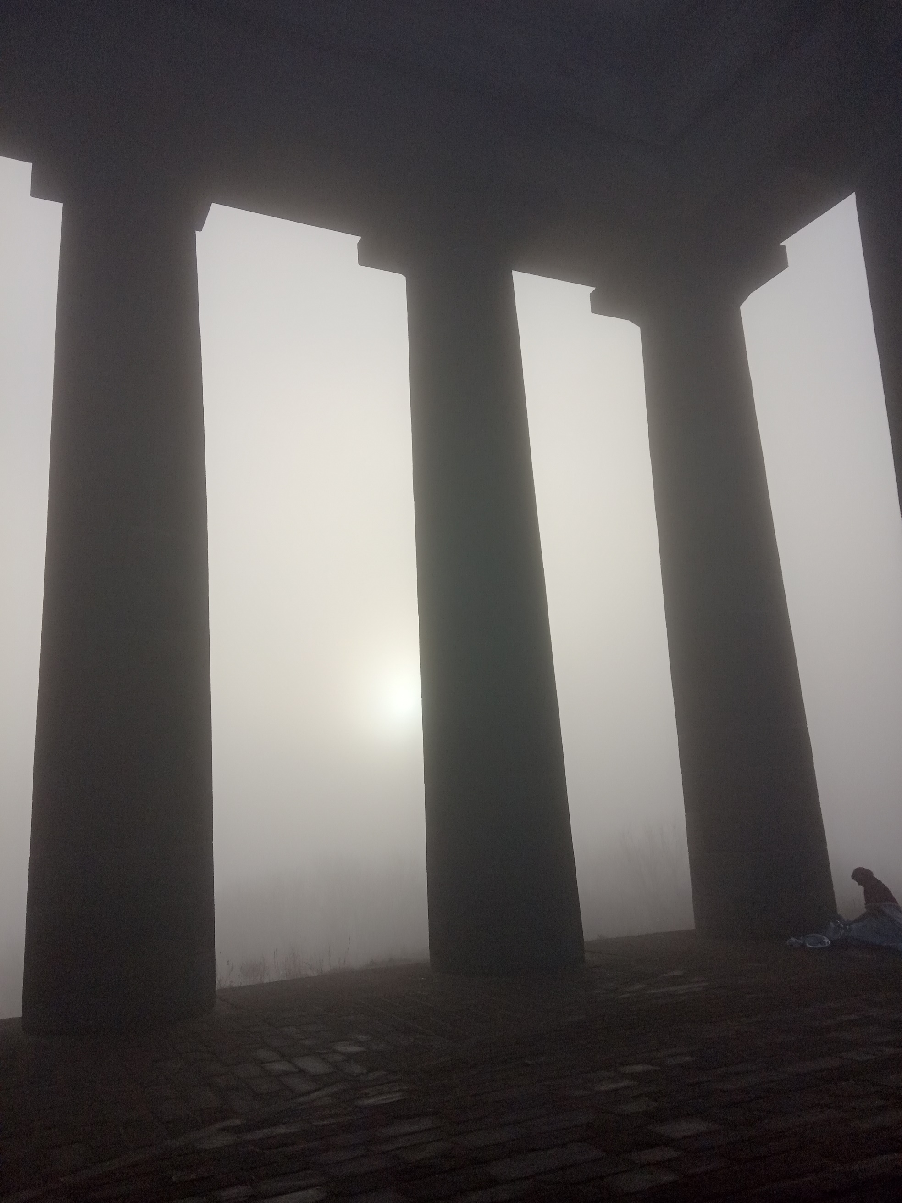
A Sunderland Symphony

Geoffrey Álvarez

1: Nil desperandum auspice Deo
“Don’t despair, trust in God.” – a celebration of Sunderland’s city motto.
2: The brassic Fish Lass
A Fish Lass (or Wife) haggles with a hinny (lady) over her produce on a brassic (freezing cold) day.
3: Jabberwocky
The first verse of Jabberwocky was printed in Mischmasch, a publication Lewis Carroll wrote for his family. The rest of the poem was written Whitburn, Sunderland based on two serpentine stories from the North-east: the Lambton and Sockburn worms.
4: Marra.

The text of Marra is from the Ryhope Little plaque detailing the life of the wife and mother of pitmen, Sarah Seed

Mother only slept in her bed at the weekend.
Father Jack and Harry worked as marras, father working the stone and the brothers the coal: all pick and shovel work. The shifts began at 10pm, 4am and 10am, only one marra working the coal face at a time.
Mother had to prepare food and hot water in rotation for the leaving and returning men, evening night and day – as well as for the children going to school, morning noon and evening. She caught what sleep she could in her chair by the fire.

5: Bede’s Death Song
The Venerable Bede died on Thursday, 26 May 735, Ascension Day, on the floor of his cell in Jarrow, singing Glory be to the Father and to the Son and to the Holy Spirit. That night he dictated a final sentence to the scribe, a boy named Wilberht, and died soon afterwards. Bede’s disciple, Cuthbert composed a letter to Cuthwin on Bede’s death, alluding to a five-line poem in the vernacular that Bede possibly composed on his deathbed, known as "Bede’s Death Song".
Whilst the poem is not definitely attributed to Bede, this orchestral song imagines that Bede is indeed composing this poem on his deathbed, taking three attempts to deliver the work in a continuous coherent stream as he slips away, being beset, as Cuthbert notes, by “frequent attacks of breathlessness" the final version the most confident, this last burst of strength, a phenomenon common to those at the liminal position between life and death. His disciple notes that his last words were the Gloria Patri. I develop this by imagining that he was inspired to deliver this text hearing the Nunc dimittis sung by the monks at the monastery where he issued his last breath. The eight bells of ‘1719’ – a creative beating heart of Sunderland, Holy Trinity Church reimagined, proclaim the joy of Bede’s ascension in the Plain Bob Major peal.

Northumbrian version
Fore thaem neidfaerae ‖ naenig uuiurthit
thoncsnotturra, ‖ than him tharf sie
to ymbhycggannae ‖ aer his hiniongae
huaet his gastae ‖ godaes aeththa yflaes
aefter deothdaege ‖ doemid uueorthae.

Modern English translation
Before the unavoidable journey ‖ nothing can be More wise-thinking, ‖ than he who Recalls with mindfulness ‖ before his going-away On whether his soul ‖ good or ill After death’s day ‖ will be judged.

© Copyright Geoffrey Álvarez 2022

